**Reg. No: 21BCE1297 Name: Vidhi Shah Date: 12/04/22**

**PPS11**

**Q1**

**Aim:**

An automobile company has serial number for engine parts starting from AA0 to FF9. The other characteristics of parts to be specified in a structure are: Year of manufacture, material and quantity manufactured.

1. Specify a structure to store information corresponding to a part.
2. Write a program to retrieve information on parts with serial numbers between BB1 and CC6.

**Procedure:**

**Input:**

Number of details to be checked, ‘n’

Serial Number of engine, ‘srno’

**Output:**

If input serial number is within the range:

Serial Number of Engine

Year of Manufacture

Material Used

Quantity Manufactured

**Algorithm:**

Step 1: Create a structure ‘engine’ with datatypes Serial number (char[]), Year (int), Material (char[]) and Quantity (int)

Step 2: Create an array of structure ‘arr’ with details of engines from serial number ‘BB1’ to ‘BB6’

**Main Function**

Step 1: Read integer variable ‘n’

Step 2: Repeat steps 3 to 6 n times

Step 3: Read char array ‘srno’

Step 4: Store length of ‘srno’ in integer variable ‘l’

Step 5: If ‘i’ is not equal to 3 then i = -1

Else If srno[0] is equal to ‘B’ then i = srno[2] - 1 - 48

Else If srno[0] is equal to ‘C’ then i = srno[2] - 1 - 48

Else i = -1

Step 6: If i is greater than 15 or i is equal to -1 then print “Does not exist in database.”

Else print the details of the engine

Step 7: Return 0

**Code:**

**Output:**

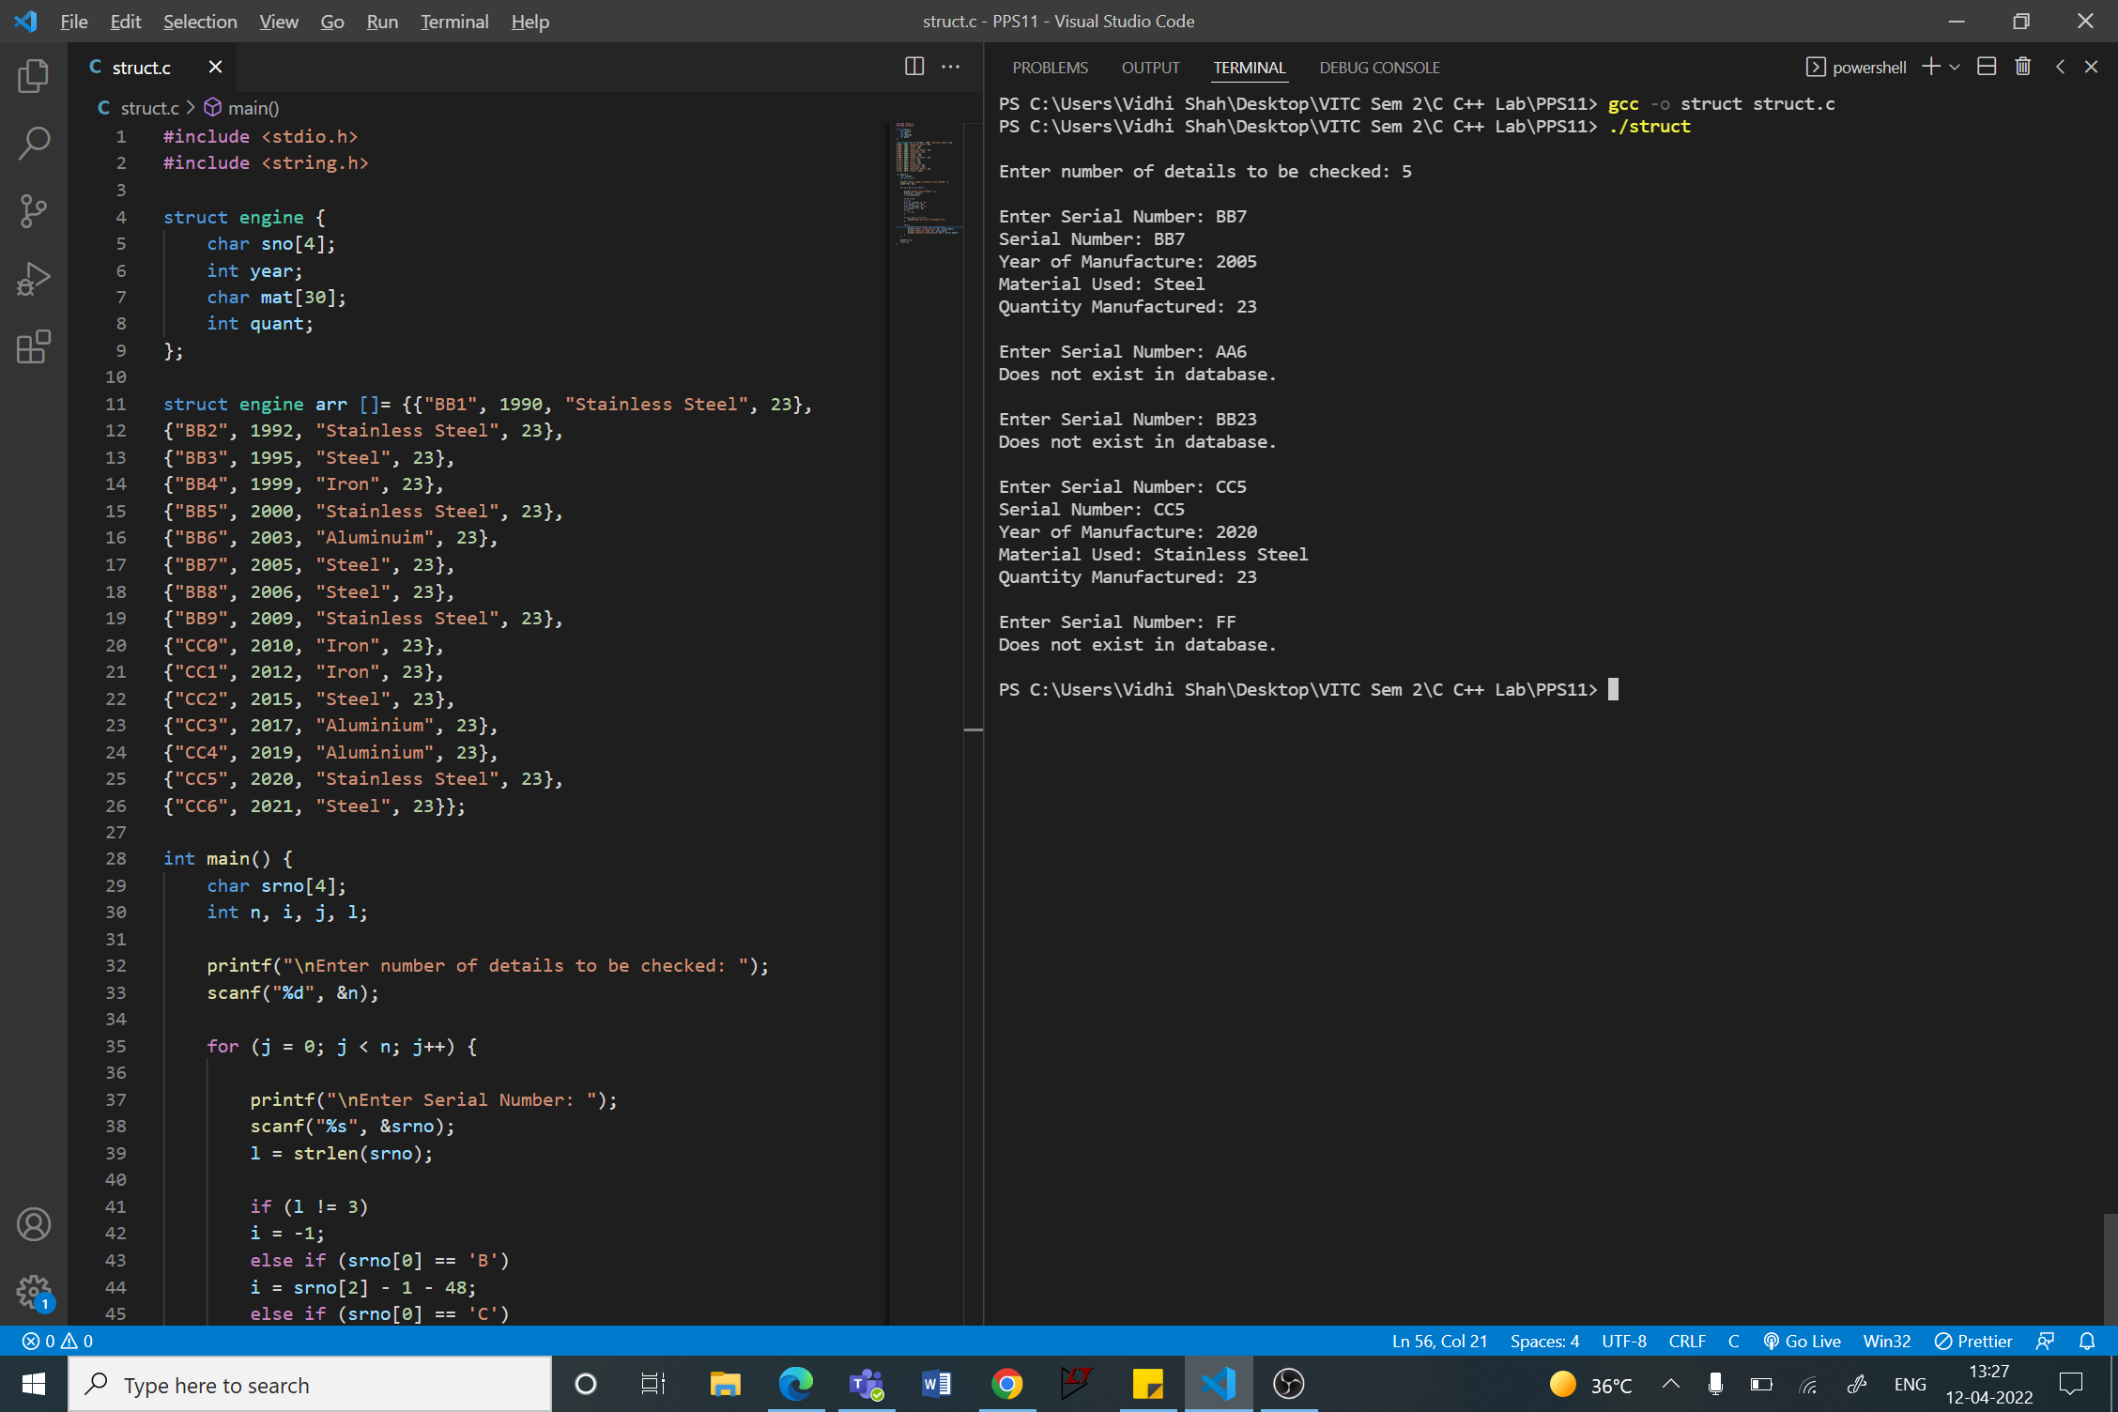

**Code:**

#include <stdio.h>

#include <string.h>

struct engine {

    char sno[4];

    int year;

    char mat[30];

    int quant;

};

struct engine arr []= {{"BB1", 1990, "Stainless Steel", 23},

{"BB2", 1992, "Stainless Steel", 23},

{"BB3", 1995, "Steel", 23},

{"BB4", 1999, "Iron", 23},

{"BB5", 2000, "Stainless Steel", 23},

{"BB6", 2003, "Aluminium", 23},

{"BB7", 2005, "Steel", 23},

{"BB8", 2006, "Steel", 23},

{"BB9", 2009, "Stainless Steel", 23},

{"CC0", 2010, "Iron", 23},

{"CC1", 2012, "Iron", 23},

{"CC2", 2015, "Steel", 23},

{"CC3", 2017, "Aluminium", 23},

{"CC4", 2019, "Aluminium", 23},

{"CC5", 2020, "Stainless Steel", 23},

{"CC6", 2021, "Steel", 23}};

int main() {

    char srno[4];

    int n, i, j, l;

    printf("\nEnter number of details to be checked: ");

    scanf("%d", &n);

    for (j = 0; j < n; j++) {

        printf("\nEnter Serial Number: ");

        scanf("%s", &srno);

        l = strlen(srno);

        if (l != 3)

        i = -1;

        else if (srno[0] == 'B')

        i = srno[2] - 1 - 48;

        else if (srno[0] == 'C')

        i = srno[2] + 9 - 48;

        else {

            i = -1;

        }

        if (i > 15 || i == -1) {

            printf("Does not exist in database.\n");

        }

        else {

            printf("Serial Number: %s", arr[i].sno);

            printf("\nYear of Manufacture: %d", arr[i].year);

            printf("\nMaterial Used: %s", arr[i].mat);

            printf("\nQuantity Manufactured: %d\n", arr[i].quant);

        }

    }

    printf("\n");

    return 0;

}

